Practical 2 b

using System;
using System.Collections.Generic;
using System.Linq;
using System.Text;
using System.Threading.Tasks;

namespace InheritanceDemo
{
class Animal
{
public void Eat() => Console.WriteLine("Animal is eating");
}
class Dog : Animal
{
public void Bark() => Console.WriteLine("Dog is Barking");
}
class GrandParent
{
public void Method1() => Console.WriteLine("GrandParent method");
}
class Parent : GrandParent
{
public void Method2() => Console.WriteLine("Parent method");
}
class Child : Parent
{
public void Method3() => Console.WriteLine("child method");

}
class Shape
{
public void Draw() => Console.WriteLine("Drawing a shape");
}
class Circle : Shape
{
public void Info() => Console.WriteLine("This is a Circle");
}
class Rectangle : Shape
{
public void Info() => Console.WriteLine("This is a rectangle");
}
interface IFlyable
{
void Fly();
}
interface ISwimmable
{
void Swim();
}
class Duck : IFlyable, ISwimmable
{
public void Fly() => Console.WriteLine("Duck can Fly");
public void Swim() => Console.WriteLine("Duck can swim");
}
class Program
{
static void Main(string[] args)
{
Console.WriteLine("-----Single Inheritance------");
Dog d = new Dog();
d.Eat();
d.Bark();
Console.WriteLine("-----Multilevel Inheritance------");
Child c = new Child();
c.Method1();
c.Method2();
c.Method3();
Console.WriteLine("-----Hierachical Inheritance------");
Circle cir = new Circle();
cir.Draw();
cir.Info();
Rectangle rec = new Rectangle();
rec.Draw();
rec.Info();
Console.WriteLine("-----Multiple Inheritance(Interface)-----");
Duck du = new Duck();
du.Fly();
du.Swim();
Console.ReadKey();
}
}
}

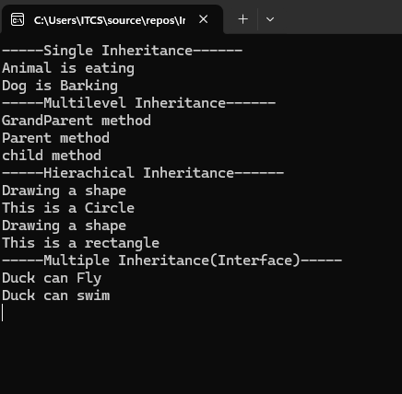

Practical 2c
using System;
using System.Collections.Generic;
using System.Linq;
using System.Text;
using System.Threading.Tasks;

namespace ConstructorOverloading
{
class Student
{
public Student()
{
Console.WriteLine("Deafult Constructor Called");
}
public Student(string name)
{
Console.WriteLine(" Student Name:" + name);
}
public Student(string name, int age)
{
Console.WriteLine("Student Name:" + name);
Console.WriteLine("Student Age:" + age);
}
}
class Program
{
static void Main()
{
Student s1 = new Student();
Student s2 = new Student("Sayali");
Student s3 = new Student("Neelam", 20);
Console.ReadLine();
}
}
}

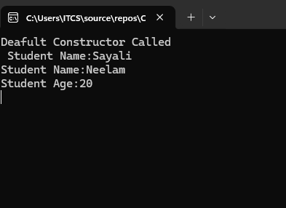

Practical no 2 d
using System;
using System.Collections.Generic;
using System.Linq;
using System.Text;
using System.Threading.Tasks;

namespace @Interface
{
interface IShape
{
void Area();
}
class Square : IShape
{
int side = 5;
public void Area()
{
Console.WriteLine("Area of Square= " + (side * side));
}
}
class Program
{
static void Main()
{
Square s = new Square();
s.Area();
Console.ReadLine();
}
}
}

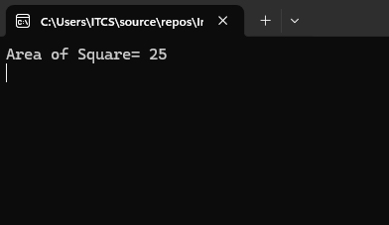

Practical 2 f
using System;
using System.Collections.Generic;
using System.Linq;
using System.Text;
using System.Threading.Tasks;

namespace ExceptionHandling
{
class Program
{
static void Main(string[] args)
{
int a, b, result;
try
{
Console.Write("Enter First Number: ");
a = Convert.ToInt32(Console.ReadLine());
Console.Write("Enter Second Number:");
b = Convert.ToInt32(Console.ReadLine());
result = a / b;
Console.WriteLine("Result =" + result);
}
catch (DivideByZeroException)
{
Console.WriteLine("Can't divide by Zero");
}
catch (FormatException)
{
Console.WriteLine("Invaild Input");
}
finally
{
Console.WriteLine("Program Ended");
}
Console.ReadLine();

}
}
}

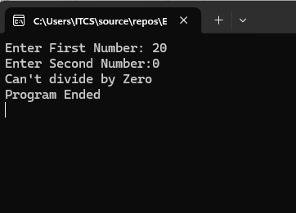
2 e

using System;
using System.Collections.Generic;
using System.Linq;
using System.Text;
using System.Threading.Tasks;

namespace Delegates
{
public delegate void Message();
class Test
{
public event Message Notify;
public void Show()
{
Console.WriteLine("Method inside Test class");
Notify();
}
}
class Program
{
public static void Display()
{
Console.WriteLine("Event Executed Successfully");
}
static void Main(string[] args)
{
Test t = new Test();
t.Notify += Display;
t.Show();
Console.ReadLine();
}
}
}

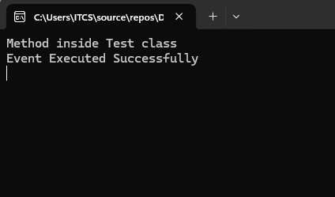

Practical 3 a
Public delegate void Calculation(int a , int b);
Class Arithmetic
{
Public void Add(int a, int b)
{
Console.WriteLine(“Addition =” (a+b));
}
Public void Subtract(int a, int b)
{
Console.WriteLine(“Subtraction =” (a-b));
}
Public void Multiply(int a, int b)
{
Console.WriteLine(“Multiplication =” (a*b));
}
Public void Divide(int a, int b)
{
Console.WriteLine(“Division =” (a/b));
}
}
Class Program
{
static void Main()
{
Arithmetic obj = new Arithmetic();
Calculation c;
c = obj.Add;
c(20, 10);
c = obj.Subtract;
c(20, 10);
c = obj.Multiply;
c(20, 10);
c = obj.Divide;
c(20, 10);
Console.ReadLine();
}
}

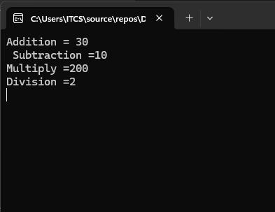

PRACTICAL 3 B
using System;
using System.Collections.Generic;
using System.Linq;
using System.Text;
using System.Threading.Tasks;

namespace MulticastDelegate
{
public delegate void Demo();
class Test
{
public void Show()
{
Console.WriteLine("Show Method Called");
}
public void Display()
{
Console.WriteLine("Diaplay Method Called");
}
public void Print()
{
Console.WriteLine("Print Method Called");
}
}

class Program
{
static void Main(string[] args)
{
Test t = new Test();
Demo d;
d = t.Show;
d += t.Display;
d += t.Print;
d();
Console.ReadLine();
}
}
}

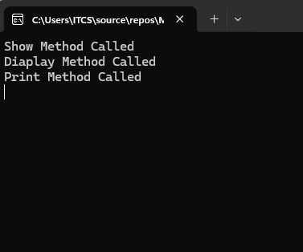

3 c
using System;
using System.Collections.Generic;
using System.Linq;
using System.Text;
using System.Threading.Tasks;

namespace BankAcc
{
class BackAccount
{
private double balance;

public double Balance
{
get
{
return balance;
}
set
{
if (value >= 0)
{
balance = value;
}
else
{
Console.WriteLine("Balance Amount cannot be negative");
}
}
}
public int AccountNumber { get; set; }
}
class Program
{
static void Main(string[] args)
{
BackAccount b = new BackAccount();
b.AccountNumber = 101;
b.Balance = 5000;
Console.WriteLine("Account Number:" + b.AccountNumber);
Console.WriteLine("Balance:" + b.Balance);
b.Balance = -2000;
Console.ReadLine();
}
}
}

